BENJAMIN PARSONS.
Art Gallery

75a Banbury Road
Oxford OX26PE
+44 (0)7432 801 256
ben@benjaminparsons.art

PAIRINGS
In collaboration with Hannah Payne Art
March 2025

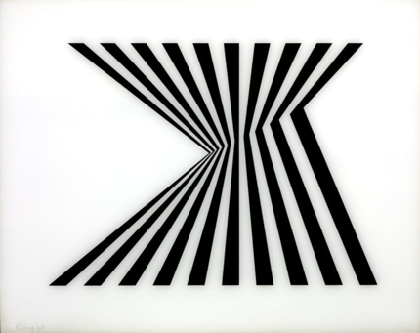 | Bridget RILEY  Untitled [Fragment 1], 1965  Screenprint on Plexiglas  Edition of 75 plus AP’s  67.3 x 83.8 cm  Framed | £ 9,500

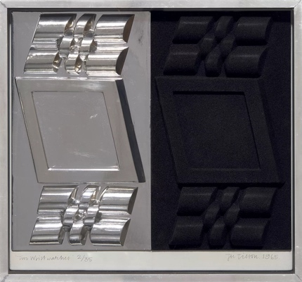 | Joe TILSON  Two Wrist Watches,1965  Vacuum-formed polystyrene in chromium plating and black flocking, contained in the original silver metal artist's frame.  68.6 x 73.7 x 7.9 cm  Edition of 35  Framed | £ 3,750

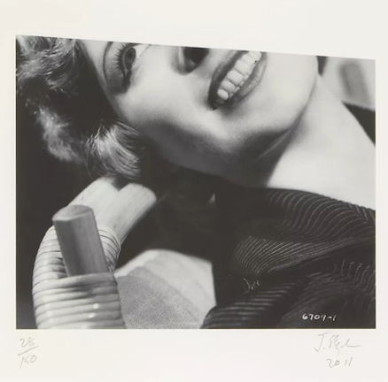 | John STAEZAKER  Untitled (Smile), 2011  Giclee on paper  38.8 x 31.8 cm  Edition of 150 plus 5 artist's proofs  Framed | £ 650
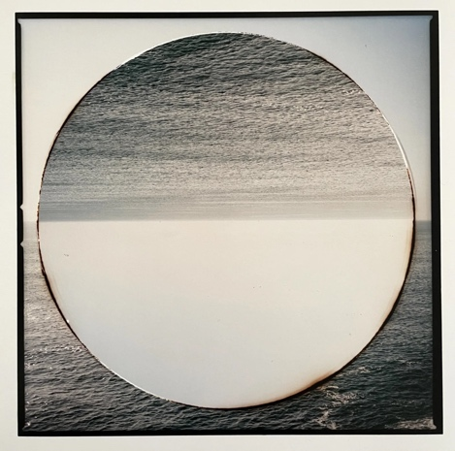 | Aliki BRAINE  The Second Day, 2020  Colour photograph from cut and repositioned negative  20 x 20 cm  Edition of 3  Framed | £ 900
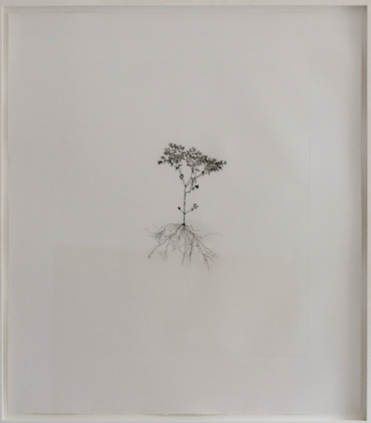 | Michael LANDY  Weed, 2003  Etching  Sheet 82 x 73 cm  Edition of 37  Framed | £ 2,750
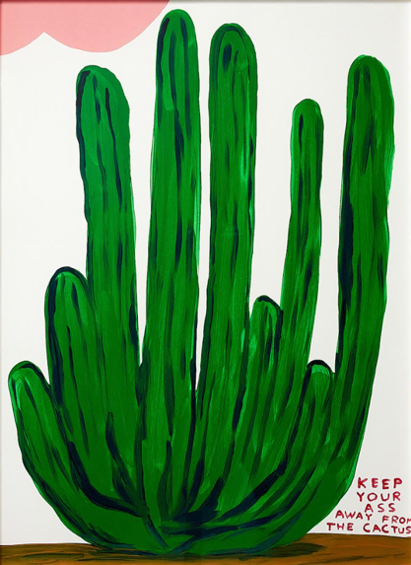 | David SHRIGLEY  Keep Your Ass Away From The Cactus 2020  Screenprint in colours, on wove  Sheet 76 x 56 cm  Edition of 125  Framed | £ 4,950
BENJAMIN PARSONS. 75a Banbury Road Oxford OX2 6PE +44 (0)7432 801 256 ben@benjaminparsons.art

