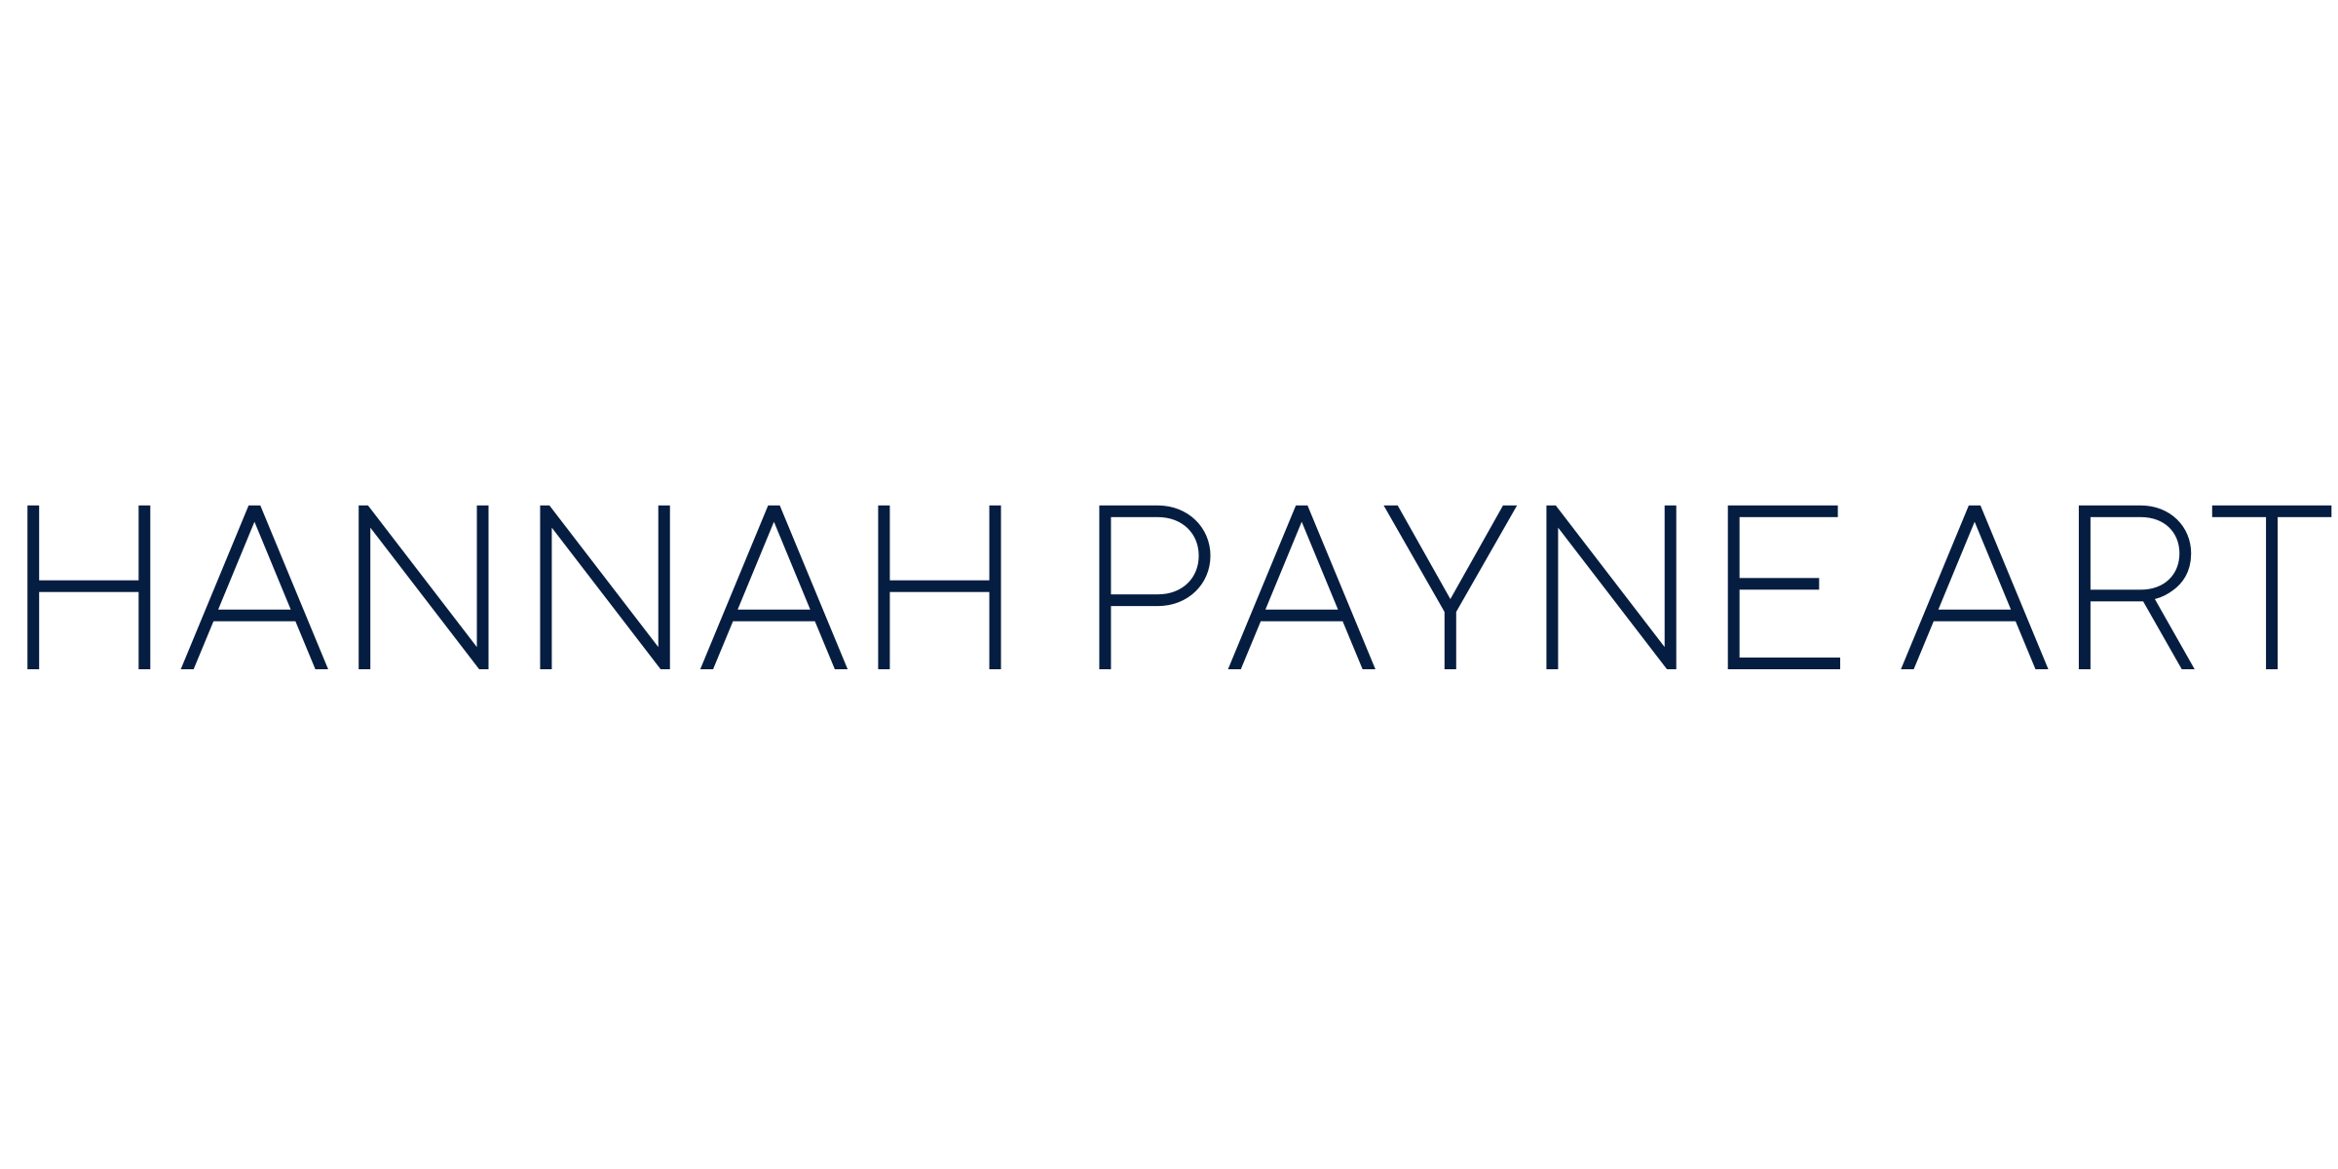

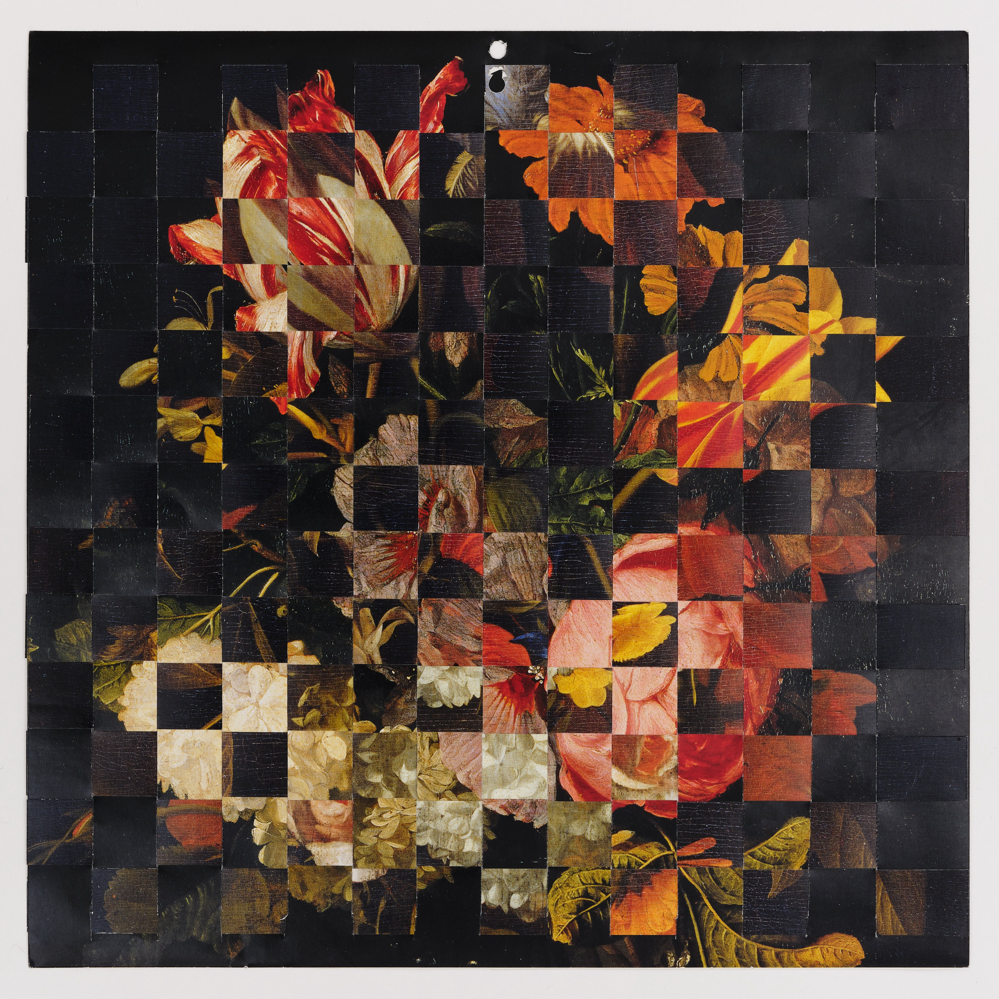

Aliki Braine | Flower Works
An online exhibition for Photo Oxford Festival
25 October – 30 November 2025

Online Exhibition presented for Photo Oxford Festival 2025
This online exhibition brings together selected works from two recent series by artist and art historian Aliki Braine - Turbulence (after…) and Twelve Months of the Year - both of which reimagine the visual language of seventeenth-century Dutch flower painting. The presentation coincides with Photo Oxford Festival 2025, whose theme, Truth, resonates deeply with Braine’s practice and her exploration of the layered realities behind photographic and art historical images.
Through her Flower Works, Braine examines the ways in which truth is constructed, reproduced, and mediated within the Western art canon. Working with colour reproductions of Dutch flower compositions sourced from old exhibition catalogues and second-hand calendars, she transforms these familiar, mass-produced images into complex meditations on authenticity, perception, and value.
In Turbulence (after…), Braine uses a rotary cutter to slice and rearrange photographic reproductions of historical bouquets, creating swirling, fractured compositions that both honour and disrupt their sources. The resulting images expose the tension between beauty and artifice, inviting viewers to question the notion of truth within these “perfect” arrangements.
In Twelve Months of the Year, Braine layers and weaves together two calendar reproductions - both derived from paintings in the Ashmolean’s collection - to create six hybrid works that speak to the passage of time and the circulation of imagery. Their digital-like pixelation and geometrical overlays evoke the visual noise of contemporary media, while alluding to the histories of trade, wealth, and colonialism embedded within the original still life paintings.
Together, these series invite reflection on how art history is mediated and reinterpreted, and how truth itself is constructed through images. Braine’s interventions blur the boundaries between image and object, past and present offering a compelling reconsideration of how we encounter and value images in an age of endless reproduction.
As part of Photo Oxford Festival, Aliki Braine will be in conversation with An Van Camp, Curator of Northern European Art at the Ashmolean Museum, on Friday 25 October at 2pm. The event will explore Braine’s practice and her works currently on temporary loan at the Ashmolean.
Booking via the Ashmolean website: ashmolean.org/event/artist-aliki-braine-in-conversation
Exhibition Details:
Dates: 25 October – 30 November, 2025
Online Exhibition.
Photo Oxford Festival Talk: 2pm, Saturday 25 October 2025. Ashmolean Museum, Oxford.
For further information, or inquiries about works available, please contact:
Hannah Payne
info@theartfive.com
hannahpayneart.co.uk
Top, Image credit: Aliki Braine, Eight Months of the Year (Aug/Sept), 2023, Woven catalogue pages, 38 x 38 cm framed

Aliki Braine was born in Paris in 1976. She has an MFA from The Ruskin School of Fine Art, Oxford University, an MA from The Slade School of Fine Art, London and an MA from The Courtauld Institute of Art where she was awarded a distinction for her masters in 17th century painting. Recent exhibitions include solo shows in London, Birmingham, Vienna, Madrid and Paris. Her work is featured in several recent publications including British Art and the Environment, Charlotte Gould and Sophie Mesplède (Routledge, 2022), Pauline Martin, L’Évidence, le vide, la vie; La photographie face à ses lacunes (Ithaque Editions, 2017) and Robert Shore, Post-Photography: The Artist with a Camera (Laurence King Pub, 2014.)
Aliki is an associate lecturer for Camberwell College of Art, University of the Arts London and a regular lecturer for Christie’s Education, the Wallace Collection and the National Gallery.
She lives and works in London.

