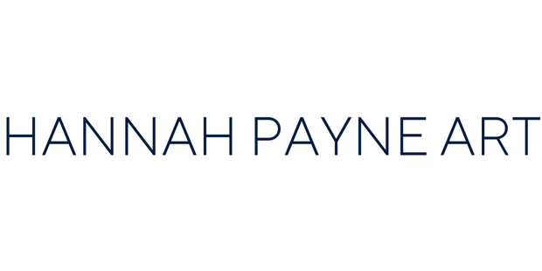

APPLICATION FORM
June 2025
ARTIST OPPORTUNITY – SOLO EXHIBITION AT WORTON KITCHEN GARDEN
Application Deadline: Sunday 30th June 2025
Hannah Payne Art, in collaboration with Worton Kitchen Garden, invites Oxford-based artists to apply for the opportunity to present a solo exhibition at this unique countryside venue, just outside Oxford.
The selected artists will have their work featured for a three-month period ( first exhibition from August 2025,) with curatorial and promotional support provided.
Works are made available for sale with a 40% gallery commission.

APPLICANT INFORMATION
Full Name: _________________________________________________
Address: ___________________________________________________

Email: ______________________________________________________
Mobile: _____________________________________________________
Instagram handle (if applicable): _______________________________

ARTIST BIO / STATEMENT
(Please include a short artist bio or statement)

(Optional) EXHIBITION OR RESIDENCY PROPOSAL
(Brief description of your exhibition idea or interest in residency)

WORK DETAILS
(Please include at least one work – up to three for review)
1. Title: ___________________________
Date: ____________________________
Medium: _________________________
Dimensions: ______________________
Price: ____________________________
2. Title: ___________________________
Date: ____________________________
Medium: _________________________
Dimensions: ______________________
Price: ____________________________
3. Title: ___________________________
Date: ____________________________
Medium: _________________________
Dimensions: ______________________
Price: ____________________________

WHO CAN APPLY
We welcome applications from artists who:
- Live, work, or have studied in Oxford
- Work in 2D media: painting, drawing, textiles, or mixed media completed within the last 5 years
- Can provide flat, wall-based works only
- Maximum size: 1 metre wide x 150 cm high
- Works on paper must be framed

ARTIST IN RESIDENCE OPPORTUNITY (Optional)
Artists who live or work in Oxfordshire may also be considered for an Artist in Residence opportunity during their exhibition period, with access to the garden and community to develop or present new work.

TO APPLY
Please email the following to info@theartfive.com by midnight, Sunday 30th June 2025
- 3 JPEGs of recent work (include title, medium, size, year)
- A short artist bio or statement
- (Optional) Brief proposal for the exhibition or residency
The selected solo exhibition will be curated by Hannah Payne Art in collaboration with Worton Kitchen Garden.

Space for optional additional text:

